Auto Ticket Classification using FLOW DESIGNER
PHASE 6 – PROJECT TESTING PHASE
1. Introduction
The Project Testing Phase is an important stage in the development of the Auto Ticket Classification system using Flow Designer. The main purpose of testing is to verify that the automated flow works correctly, classifies incoming tickets according to the defined conditions, and produces the expected results. Testing also helps identify configuration errors, incorrect conditions, missing field values, and unexpected system behavior before the solution is used in a live environment.
In this project, the Flow Designer is tested with different ticket inputs and scenarios. The test cases cover normal requests, different categories, priority conditions, incomplete information, and other possible variations. The actual output of each test is compared with the expected output to confirm that the automation behaves as designed.
2. Objectives of Project Testing
The major objectives of the testing phase are to validate the complete flow, ensure correct ticket classification, verify that conditions and actions execute in the correct order, confirm that required fields are handled properly, and detect errors before deployment. Testing also provides evidence that the automated process meets the functional requirements of the project.
3. Testing Environment
3.1 Flow Designer
The Auto Ticket Classification workflow is implemented and executed using Flow Designer. The flow contains a trigger, conditions, decision logic, and actions that process the ticket and assign the appropriate classification.
3.2 Test Data
Different sample tickets are used as test data. Each ticket contains values such as short description, category, priority, and other relevant fields required by the flow. The test data is selected to represent common as well as exceptional ticket conditions.
4. Test Case Execution
Each test case is executed by submitting a ticket that satisfies a particular condition. The flow is then allowed to process the ticket automatically. The generated result is checked against the expected classification. If the actual result matches the expected result, the test case is considered successful.
5. Sample Test Cases
5.1 Valid Ticket Classification
A ticket containing valid and complete information is submitted. The Flow Designer identifies the relevant conditions and assigns the expected ticket classification. This test confirms that the basic automation works correctly.
5.2 Different Ticket Categories
Tickets belonging to different categories are tested individually. The flow must recognize the specified conditions and classify each ticket according to the configured business rules.
5.3 Priority-Based Testing
Tickets with different priority values are tested to verify that priority-related conditions are evaluated correctly. The resulting classification and subsequent actions are checked against the expected behavior.
5.4 Missing or Incomplete Information
Tickets with missing or incomplete field values are used to check how the flow handles unexpected or insufficient input. The system should process the ticket according to the configured conditions without producing an incorrect classification.
6. Expected Result
For every valid test case, the Flow Designer should execute the configured steps in the correct sequence and assign the appropriate classification to the ticket. The expected result is that the automated classification is consistent with the rules defined in the project.
7. Actual Result
The actual result is obtained after executing each test case. The ticket fields and flow execution details are checked to determine whether the expected classification and actions were produced. Successful execution confirms that the configured flow is functioning as intended.
8. Test Validation
The test results are reviewed to validate the overall behavior of the automation. Any mismatch between the expected and actual results is investigated by checking the trigger, conditions, field values, and actions in Flow Designer. Corrections are made where necessary and the affected test cases are executed again.
9. Testing Outcome
The testing phase demonstrates whether the Auto Ticket Classification workflow can reliably process tickets and apply the configured classification rules. A successful test cycle provides confidence that the flow is ready for the next stage of the project, subject to final review and deployment requirements.
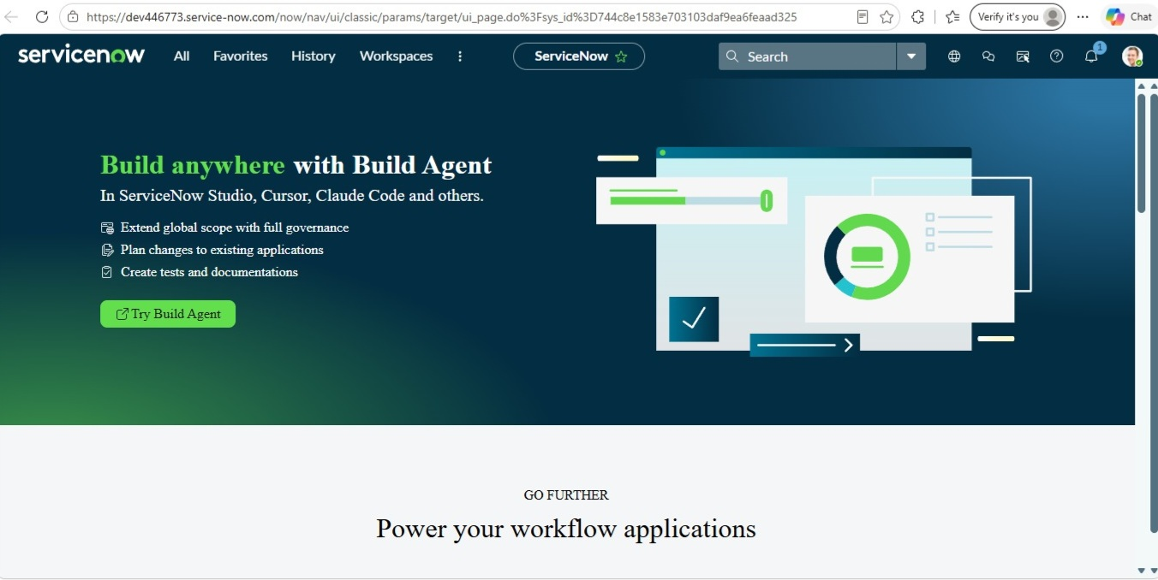
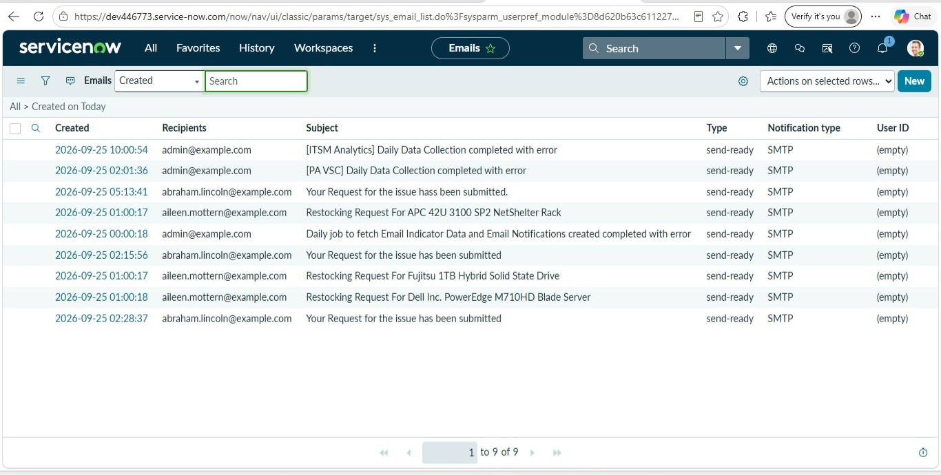
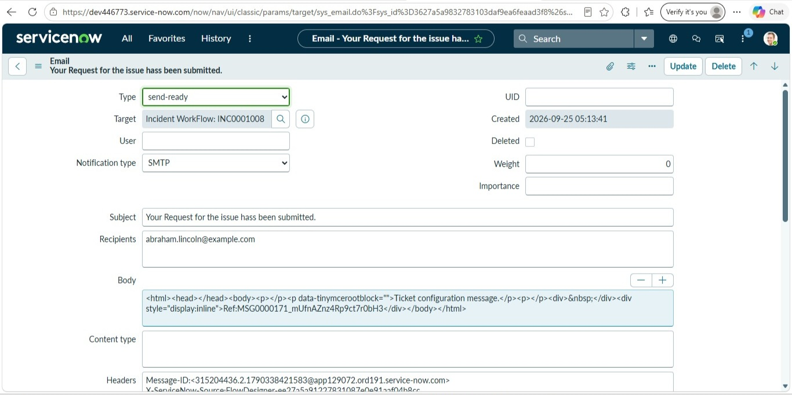
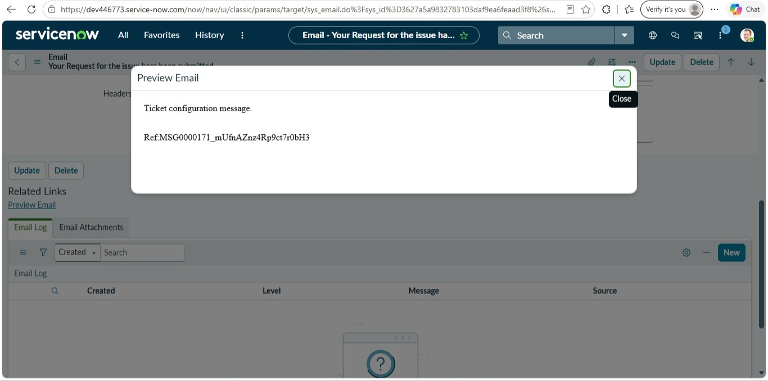
10. Conclusion
The Project Testing Phase verifies the functionality and reliability of the Auto Ticket Classification system developed using Flow Designer. By executing multiple test scenarios and comparing expected and actual results, the project confirms that the automation performs its intended classification tasks. Testing therefore plays a key role in ensuring that the final workflow is accurate, consistent, and suitable for practical use.

